SIMATS ENGINEERING
ASSESSMENT TOOL 1

COURSE CODE: CSA1442 COURSE NAME: Compiler Design for Higher
Level Processing

COURSE OUTCOME COVERED

CO2: Construct top-down and bottom up parsers using CFG for parsing conflicts and error recovery for efficient syntax tree generation. (BL3)

Assessment Tool Weightage: 40%

QUESTIONS:4 Total Marks:50
Annexure A

DESIGN TASK

Code of Conduct:

I ____________________ (Name / Reg No) certify that this submission is my original work and that I have adhered to the guidelines specified for this assessment.
I understand that any violation of academic integrity rules will result in disciplinary action.

Signature of the student:

Course Faculty

Annexure A

DESIGN TASK

Q1. Shift-Reduce Parsing (Application Level)
Task:
Apply shift-reduce parsing to the given grammar and input string, and demonstrate the complete parsing process by showing each step with stack contents, remaining input, and parsing actions (shift, reduce, accept, or error), clearly indicating all reductions and decisions made during parsing.

Grammar:
E → E + E
E → E * E
E → id
Conditions:
- Show stack, input buffer, and action at each step
- Resolve conflicts using precedence (* has higher precedence than +*)
Test Case:
Input:
id + id * id
Expected Output:
- Sequence of actions: Shift / Reduce / Accept
- Final result: String Accepted

Integrated Design Question (SLR, LALR, CLR Parsing)
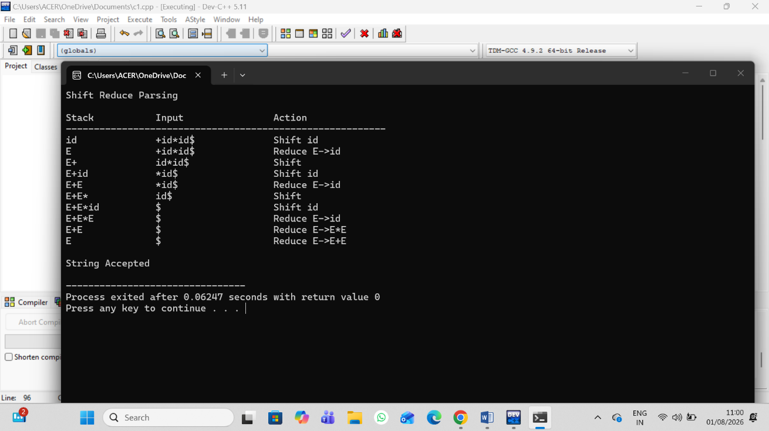

Q4. Critically evaluate the effectiveness of Parsing Expression Grammars (PEG) as a modern parsing technique by comparing them with traditional LL and LR parsers in terms of ambiguity handling, grammar expressiveness, implementation complexity, performance, and real-world applicability.

Your answer should:
- Analyze how PEG parsers resolve ambiguity differently from CFG-based parsers
- Compare PEG with LL and LR parsing in terms of:
  - Grammar expressiveness
  - Ease of implementation
  - Performance and backtracking
- Examine real-world adoption (e.g., Python’s PEG parser) and justify why PEG was preferred
- Critically evaluate limitations of PEG (e.g., lack of left recursion support, ordered choice behavior)
- Conclude whether PEG is suitable for all programming languages or only specific cases, with justification
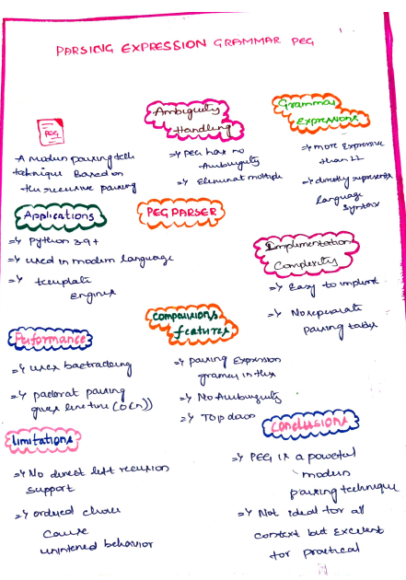
Q 5. Advanced LL(1) Parser Evaluation and Design
Task:
Analyze and redesign the given grammar to make it suitable for LL(1) parsing, construct the predictive parsing table, and evaluate its correctness by parsing the input string.
Grammar:
S → S + T | T
T → T * F | F
F → (S) | id
Conditions:
- Eliminate left recursion completely
- Apply left factoring where necessary
- Compute FIRST and FOLLOW sets accurately
- Construct the LL(1) parsing table
- Justify whether the grammar satisfies LL(1) conditions
- Trace full parsing steps with stack, input, and action
Test Case:
Input: id + id * id
Expected: String Accepted with full trace
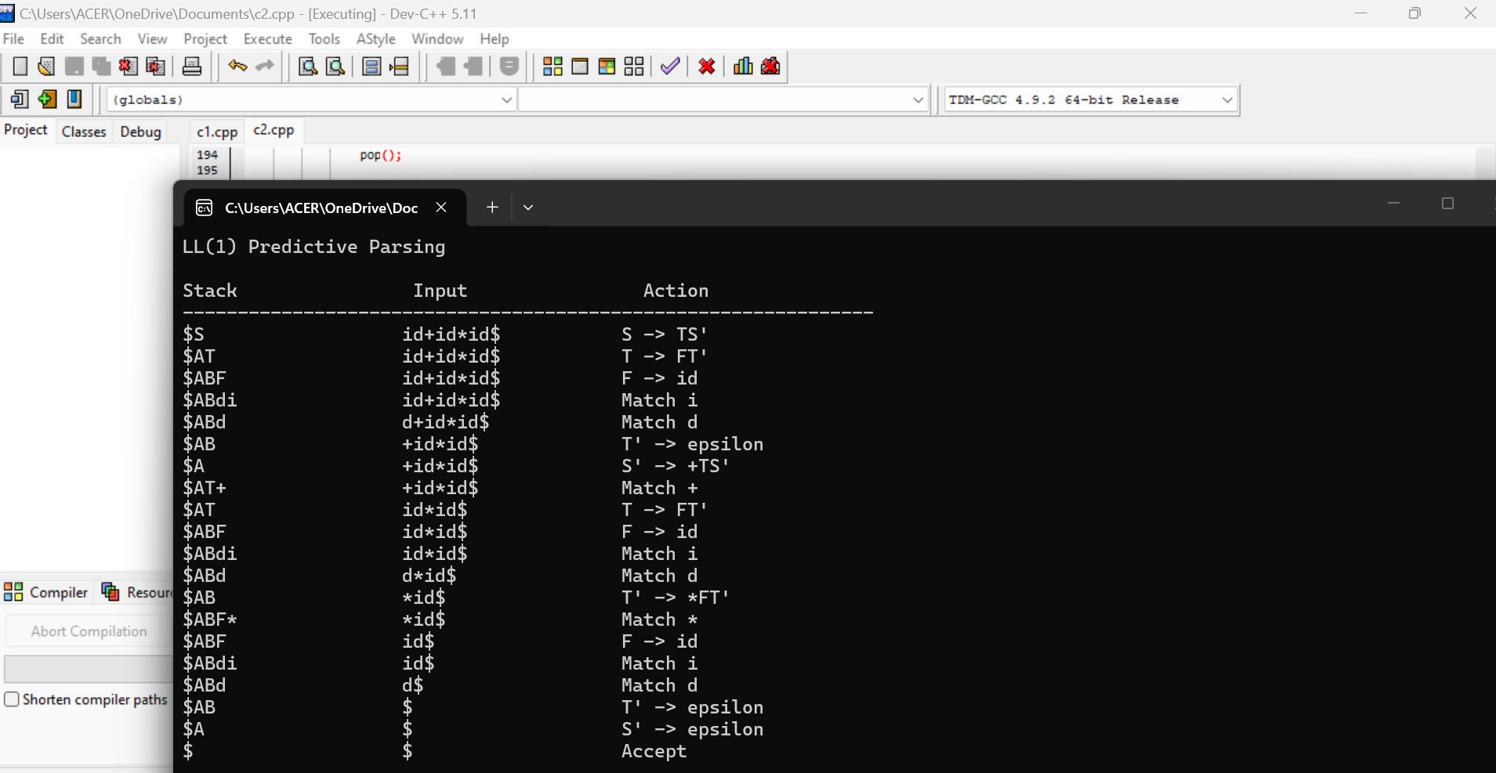

Q7. Operator Precedence Parsing Design and Evaluation
Task:
Design an operator precedence parser and evaluate its correctness for handling precedence and associativity.
Grammar:
E → E + E | E * E | (E) | id
Conditions:
- Define operator precedence relations (<, =, >)
- Construct precedence table
- Handle associativity rules explicitly
- Detect and resolve conflicts
- Show step-by-step parsing actions
- Evaluate correctness of parsing decisions
Test Case:
Input: id + id * id
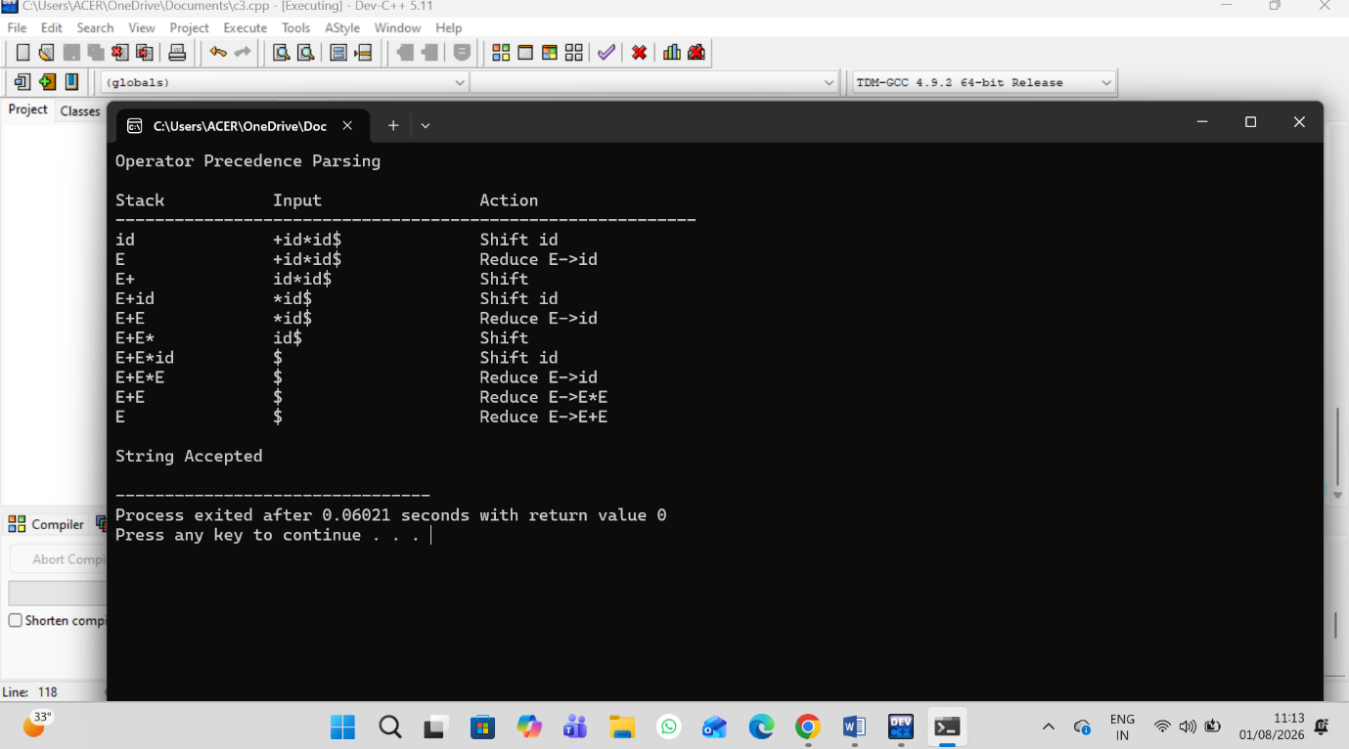

RUBRICS FOR CALCULATION:

Criteria | Weightage | Level 4 – Exemplary | Level 3 – Proficient | Level 2 – Developing | Level 1 – Beginning
Understanding of Concepts | 20 | Demonstrates thorough understanding and integrates multiple concepts effectively | Good understanding with proper integration of most concepts | Basic understanding with partial integration | Poor understanding with no integration
Design & Implementation | 25 | Well-designed solution with systematic and optimal implementation | Correct design with minor issues | Basic design with errors or inefficiencies | Incorrect or incomplete design
Parser/Algorithm Construction | 20 | Accurate construction of parser/algorithm with complete logic | Mostly correct construction with minor errors | Partial construction with missing logic | Incorrect or incomplete construction
Analysis & Validation | 15 | Insightful analysis with correct validation and justification | Good analysis with reasonable justification | Basic analysis with limited validation | Poor or incorrect analysis
Documentation & Presentation | 20 | Well-structured documentation with diagrams, steps, and clarity | Organized documentation with required details | Basic documentation with missing details | Poor or incomplete documentation

